1. Problem 1
   1. Hinge Loss: $f\left(w,b\right)=\sum_{i=1}^{m}{max⁡(0,1-y_{i}\left(w^{T}x_{i}+b\right))}$. 0-1 Loss:

$L_{\frac{0}{1}}\left(z\right)=\left\{\begin{aligned}1,z<0 \\ 0,z≥0\end{aligned}\right.$ LogReg Loss: $f\left(w,b\right)=\sum_{i=1}^{m}{log⁡(1+\exp\left(-y_{i}\left(w^{T}x_{i}+b\right)\right))}.$ In terms of the functions, hinge and logistic loss are both convex when plotted on the unified graph.

* 1. A point not on the boundary is not a support vector, and it does not affect the decision boundary. However, LogReg uses all data points so the loss function takes all points into account.

1. Problem 2
   1. Using the singular value decomposition of **A**, we have

$AA^{T}= UΣV^{T}VΣ^{T}U^{T}$ = $UΣIΣU^{T}=UΣ^{2}U^{T}$**.** Thus, the columns of **U** are the eigenvectors of .

* 1. Similarly, $A^{T}A= VΣ^{T}U^{T}UΣV^{T}$ = $VΣIΣV^{T}=VΣ^{2}V^{T}$. Thus, the columns of **V** are the eigenvectors of $A^{T}A$.

1. We have a symmetric matrix in our eigen-decomposition, therefore $$SVD\left(A\right)=SVD[\left(\begin{matrix}u_{11} & u_{11} & u_{13} \\ u_{21} & u_{22} & u_{23} \\ u_{31} & u_{32} & u_{33}\end{matrix}\right)\left(\begin{matrix}3 & 0 & 0 \\ 0 & -2 & 0 \\ 0 & 0 & 1\end{matrix}\right)\left(\begin{matrix}u_{11} & u_{21} & u_{31} \\ u_{12} & u_{22} & u_{32} \\ u_{13} & u_{32} & u_{33}\end{matrix}\right)]=\left(\begin{matrix}u_{11} & -u_{11} & u_{13} \\ u_{21} & -u_{22} & u_{23} \\ u_{31} & {-u}_{32} & u_{33}\end{matrix}\right)\left(\begin{matrix}3 & 0 & 0 \\ 0 & 2 & 0 \\ 0 & 0 & 1\end{matrix}\right)\left(\begin{matrix}u_{11} & u_{21} & u_{31} \\ u_{12} & u_{22} & u_{32} \\ u_{13} & u_{32} & u_{33}\end{matrix}\right)$$
2. To calculate PCA, we first have to center our matrix X. This is done by the formula: $\overline{X}=\frac{1}{n}X1_{n}$**.** We then subtract this from X. $\tilde{X}=(X- \overline{X}1_{n}^{T})$**.** From here, we can compute the covariance matrix and use eigenvalues and eigenvectors. $C=\frac{1}{n}\sum_{i=1}^{n}{\left(x_{i}-\overline{x}\right){\left(x_{i}-\overline{x}\right)}^{T}=\frac{1}{n}}\tilde{X}{\tilde{X}}^{T}∈R^{p×p}$ but this would be difficult for large p. Therefore, we instead take the singular value decomposition. $\tilde{X}=UΣV^{T}→G=U_{k}∈R^{p×k}$. We can then get the projected features $Z∈R^{p×k}=G^{T}\tilde{X}$. The minimum reconstruction error property is as follows: $GG^{T}\tilde{X}=B^{*}=\underset{B:rank\left(B\right)≤k}{argmin}{{\left|\left|\tilde{X}-B\right|\right|}_{F}}$. You get the reconstruction by the formula

$\tilde{X}=GZ$.

1. On separate paper!
2. Here are the images from the reconstructions at k=10,50,100, and 200 respectively on both images:

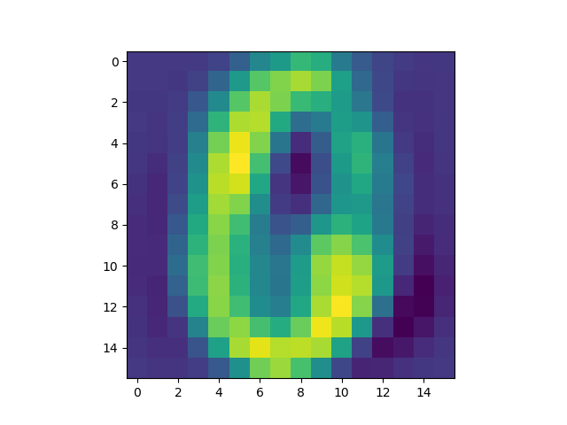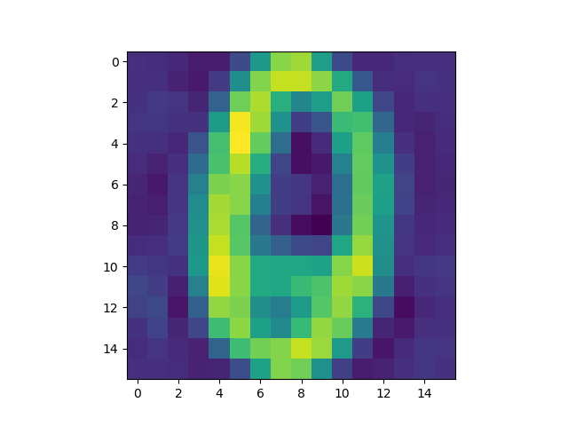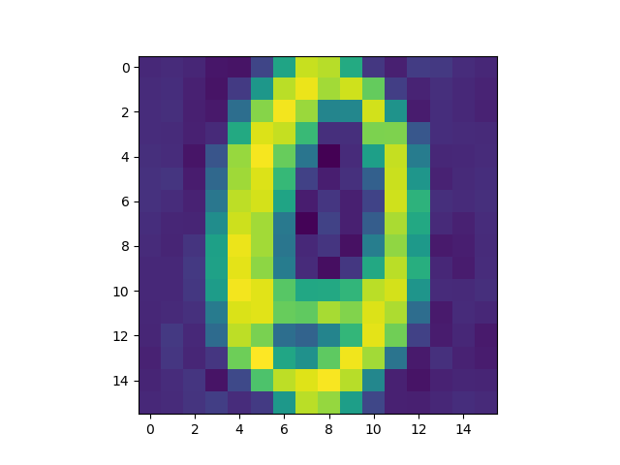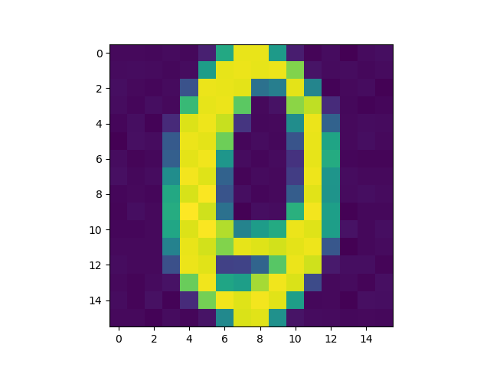

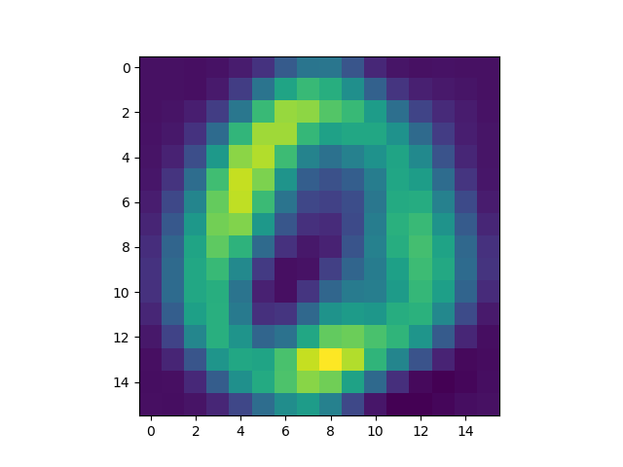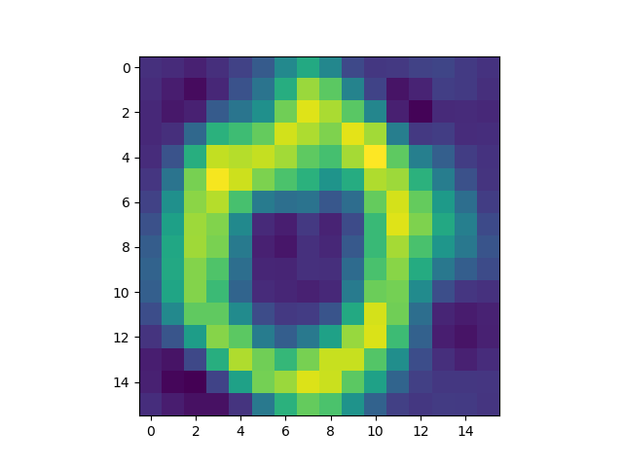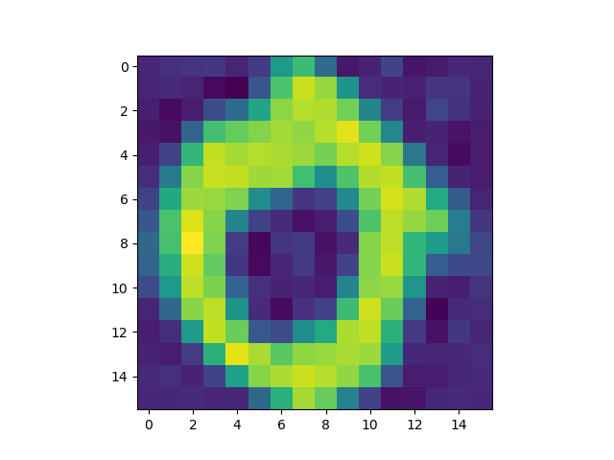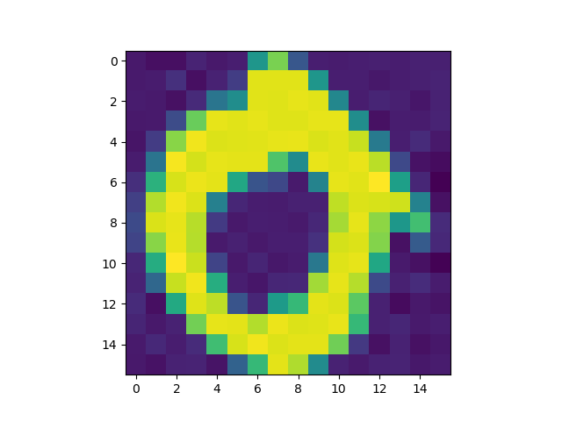

Program execution gives us the following error values: 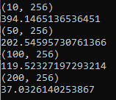

We can observe that as we preserve more components of our data, we have lower reconstruction error. This is because when k is higher, there is lower dimensionality reduction.